Install docker on EC2 and explore the docker commands (docker images, containers, volumes, network)

The Docker Engine facilitates efficient containerization and helps optimize the deployment and management processes. CentOS and Redhat are enterprise-based Linux distributions. Working on this using containerization technology enhances productivity by containerizing your applications and managing them separately. In this article, we will go on to discuss step-by-step how to setup the Debian operating system on top of AWS and step-by-step guidance for the installation of Docker on this.

CENTOS:

CentOS stands for Community Enterprise Operating System, is an open-source, freely available Linux distribution that is known for its stability and reliability. It is derived and developed from the upstream source code of the popular enterprise operating system, Red Hat Enterprise Linux (RHEL). CentOS comes with a strong community-supporting platform that will be ideal for server environments. It offers a secured and scalable base for various applications. It comes with long-term support and compatibility, and it is widely adopted for hosting servers, both in enterprise and community settings.

DOCKER ENGINE :

Docker Engine is a powerful containerization platform that helps simplify the deployment and management of applications by encapsulating them into lightweight, portable containers. These Docker platform containers include the application code, runtime, libraries, and system tools, ensuring consistent performance across different environments. Docker Engine will provide efficient isolation, scalability, and portability of applications, making it a popular choice for developers and system administrators.

How to Install Docker Engine on CentOS

Step 1: Login to the Amazon Console

Firstly, navigate to the AWS account login console.

Log in with your AWS account credentials.

Step 2: Navigate To EC2 Dashboard

After login in with your credentials, navigate to EC2 dashboard from the console home.

Click on the "Launch Instances" to create an instance.

Step 3: Choose Centos AMI Image

Provide the Name to the creating instance.

In selecting AMI click on "browse more AMI".

specify the number of the instances section with 1.

Then search for centos based AMIs in the search box.

Select the first coming centos AMI images as shown in the below screenshot.

After selecting you will be directed as shown in the below screenshot. select for "subcribing on Instance Launch".

After choosing the centos latest versioned AMI, select the instance type t2.micro.

Select the existing ssh key if available or create new ssh key pair.

Now click on Edit option beside the network security groups.

Configure the Network security groups, with enabling all the traffic to not face any issues from the AWS network end.

Configure the settings with All traffic , all ports and protocols and accessing any inbound traffic from any sourceIP as shown in the below screenshot.

Step 4: Connect To The Instance

Wait for the status of the created instance come to running state from the pending state.

After once, the instance came to the running state, select the instance and connect to it.

Step 5: Go For SSH Connection With Local System

After connecting go to the SSH section.

From that ssh section copy the ssh command.

Go to the local system command line, redirect to the ssh key containing directory.

Run this copied ssh command their and connect to the CentOs instance remoted from the local system.

Step 6: Update The System Software

After once connected to the Instance update the system with the following command:

sudo yum update -y

The following screenshot shows practical about updating the system with the above command.

Step 7: Install Docker Dependencies

Install the docker dependencies such as yum-utils, device-mapper-persistent-data and lvm2 software drivers with the following command:

sudo yum install -y yum-utils device-mapper-persistent-data lvm2

The following screenshots show the installation of docker dependencies practically.

Step 8: Add Docker Repository

Now add docker repository to this debain Operating system with running the following command:

sudo yum-config-manager --add-repo https://download.docker.com/linux/centos/docker-ce.repo

The following screenshot show clearly on executing the above command it results adding of registry kind of message.

Step 9: Install Docker Engine

Install the Docker Engine using yum packager with following command:

sudo yum install -y docker-ce docker-ce-cli containerd.io

The following screenshot illustrates the installation of docker-ce, docker-ce-cli and containerd.io softwares.

Step 10: Start and Enable Docker

Start the Docker service and enable it to start on boot with the following commands.

sudo systemctl start docker
sudo systemctl enable docker

Step 11: Verify Installation
Check Docker version and run a test container with the following commands.

docker --version
docker run hello-world

How to Upgrade Docker on Centos

Step 1: Check the Current Version of Docker

Before updating, check the current version of Docker installed on your system:

docker --version

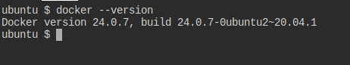

Step 2: Uninstall the Old Version of Docker (Optional)

While it’s optional, you may choose to uninstall the old version of Docker. You can uninstall Docker without removing images, docker containers, docker volumes, or configuration files.

sudo apt-get remove docker docker.io containerd runc

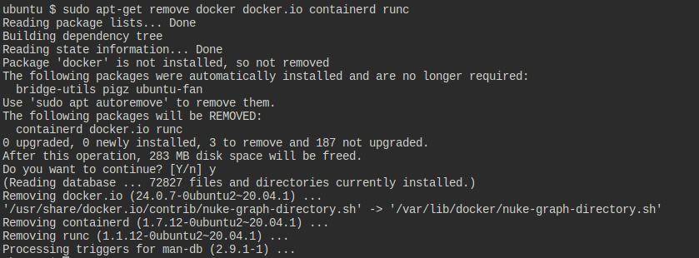

Step 3: Update the Package Repository

Make sure your package repository is up-to-date before updating Docker:

sudo apt-get update

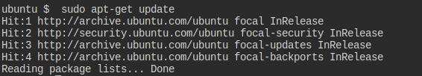

Step 4: Install Prerequisites

You need to install some prerequisite packages:

sudo apt-get install apt-transport-https ca-certificates curl software-properties-common

Step 5: Add Docker’s Official GPG Key

Add Docker's GPG key for verification:

curl -fsSL https://download.docker.com/linux/ubuntu//gpg | sudo gpg --dearmor -o /usr/share/keyrings/docker-archive-keyring.gpg

Step 6: Set Up Docker’s APT Repository

echo "deb [arch=$(dpkg --print-architecture) signed-by=/usr/share/keyrings/docker-archive-keyring.gpg] https://download.docker.com/linux/ubuntu/ $(lsb_release -cs) stable" | sudo tee /etc/apt/sources.list.d/docker.list > /dev/null

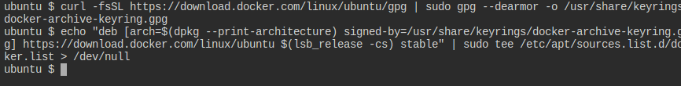

Step 7: Update Package List Again

After adding Docker’s repository, update your package list again:

sudo apt-get update

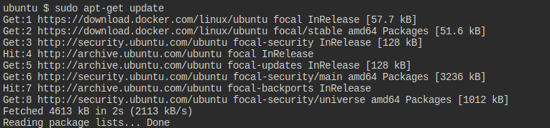

Step 8: Install Docker (or Update)

If Docker is already installed, this command will update it to the latest version. Otherwise, it will install Docker:

sudo apt-get install docker-ce docker-ce-cli containerd.io
docker-buildx-plugin docker-compose-plugin

If the above command is not working then first execute the following command and then execute the above. (only step 9)

Step 9: Unmask the Docker Service

Run the following command to unmask the Docker service:
sudo systemctl unmask docker

Step 10: Start the Docker Service

After unmasking, you can start the Docker service with:

sudo systemctl start docker

Step 11: Enable Docker to Start at Boot

To ensure Docker starts automatically on system boot, run:

sudo systemctl enable docker

Step 12: Verify Docker is Running

You can check if Docker is running with:

sudo systemctl status docker

Step 13: Verify Docker Version

To verify that Docker has been updated successfully, check the version again:

docker --version

Step 14: Test Docker

Finally, to ensure that Docker is working properly after the update, run a test container:

docker run hello-world

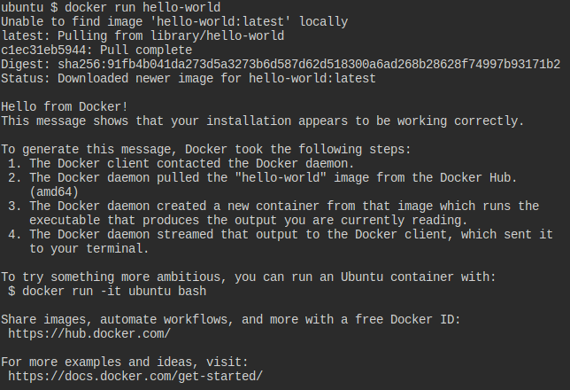

Steps To Create and Install Docker On AWS EC2

1. Create and launch EC2 instance:

Step 1: On the Dashboard of EC2, click on "Launch instance".

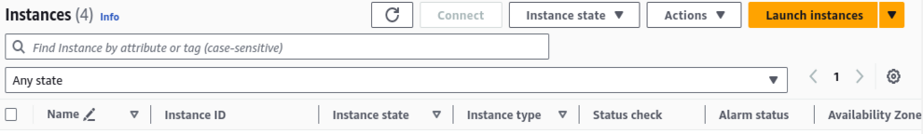

Step 2: Put any name and choose AMI Image.

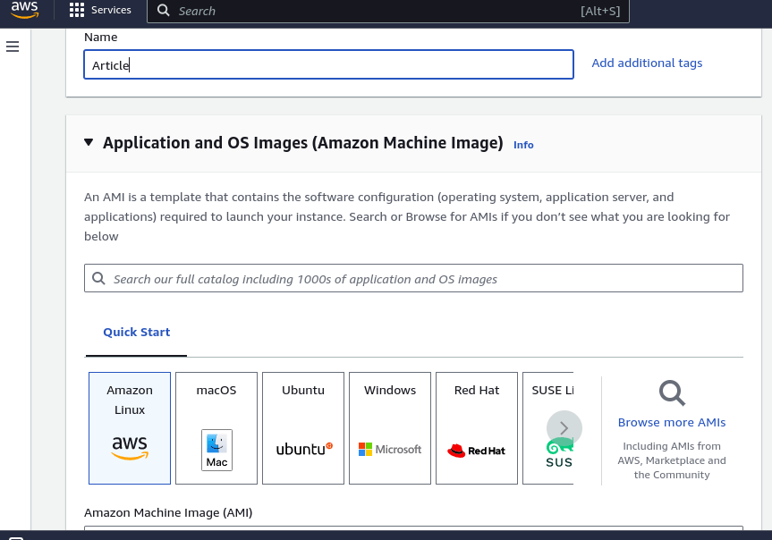

Step 3: Choose the instance type , I have choosed t2.micro because it is free.

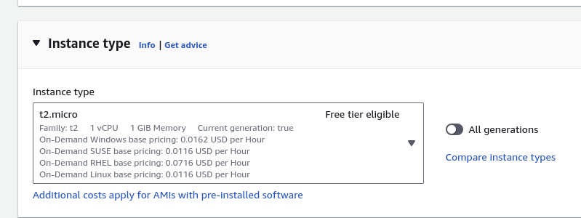

Step 4: Click on "create new key pair" and download the file.

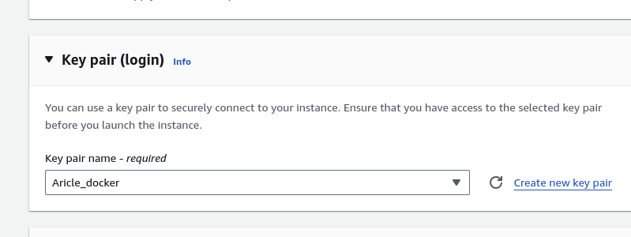

Step 5: Click on Launch instance.

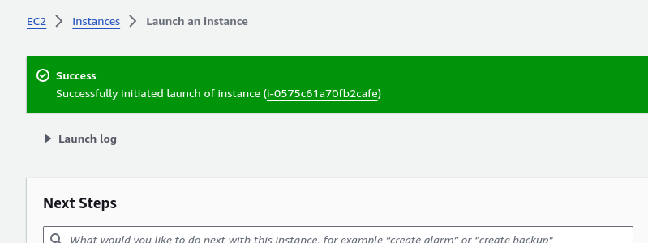

Step 6: Select your instance and click on "connect".

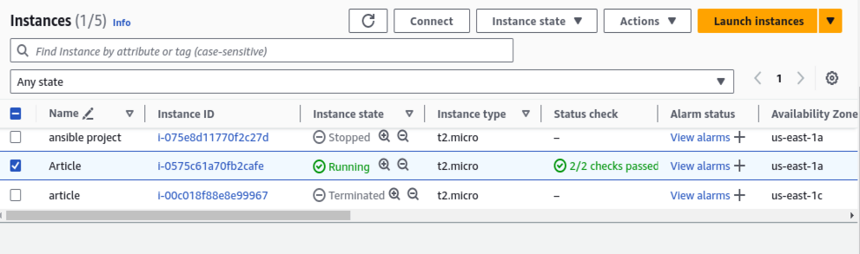

Step 7: Connect your instance.

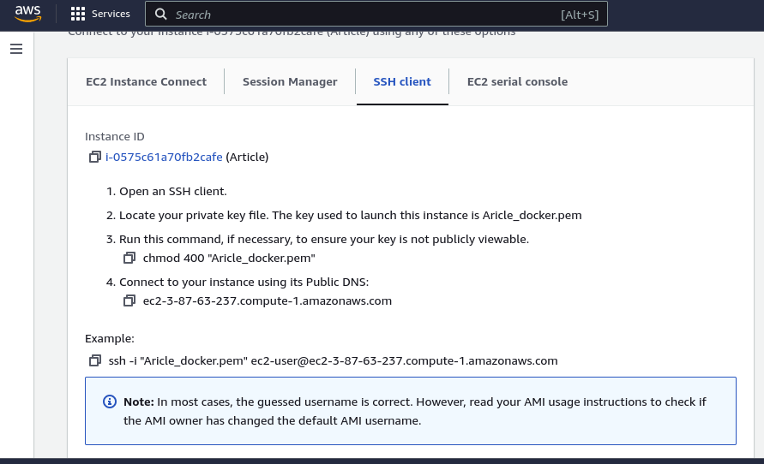

2.Install docker on Amazon EC2 instance

Step 1: Update the system and Install the latest package of "Docker".

sudo yum update -y
sudo yum install docker -y

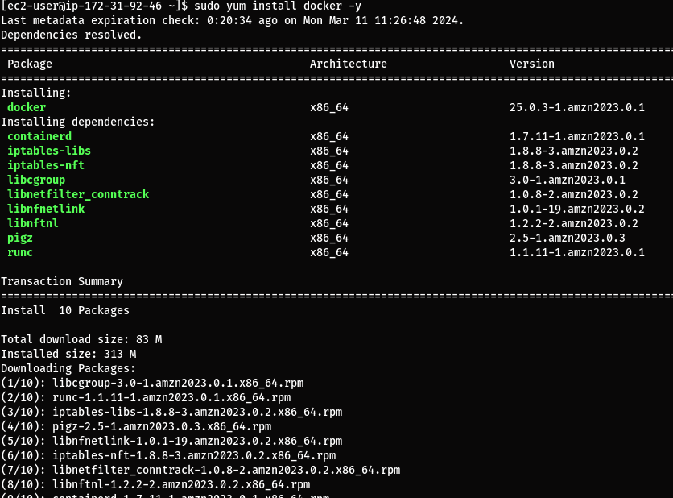

Step 2: Start the service of "Docker".

sudo systemctl start docker

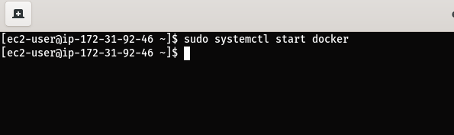

Check whether the Docker has successfully installed and service is active.

sudo systemctl status docker

